FREEDOM
ENCOUNTERS
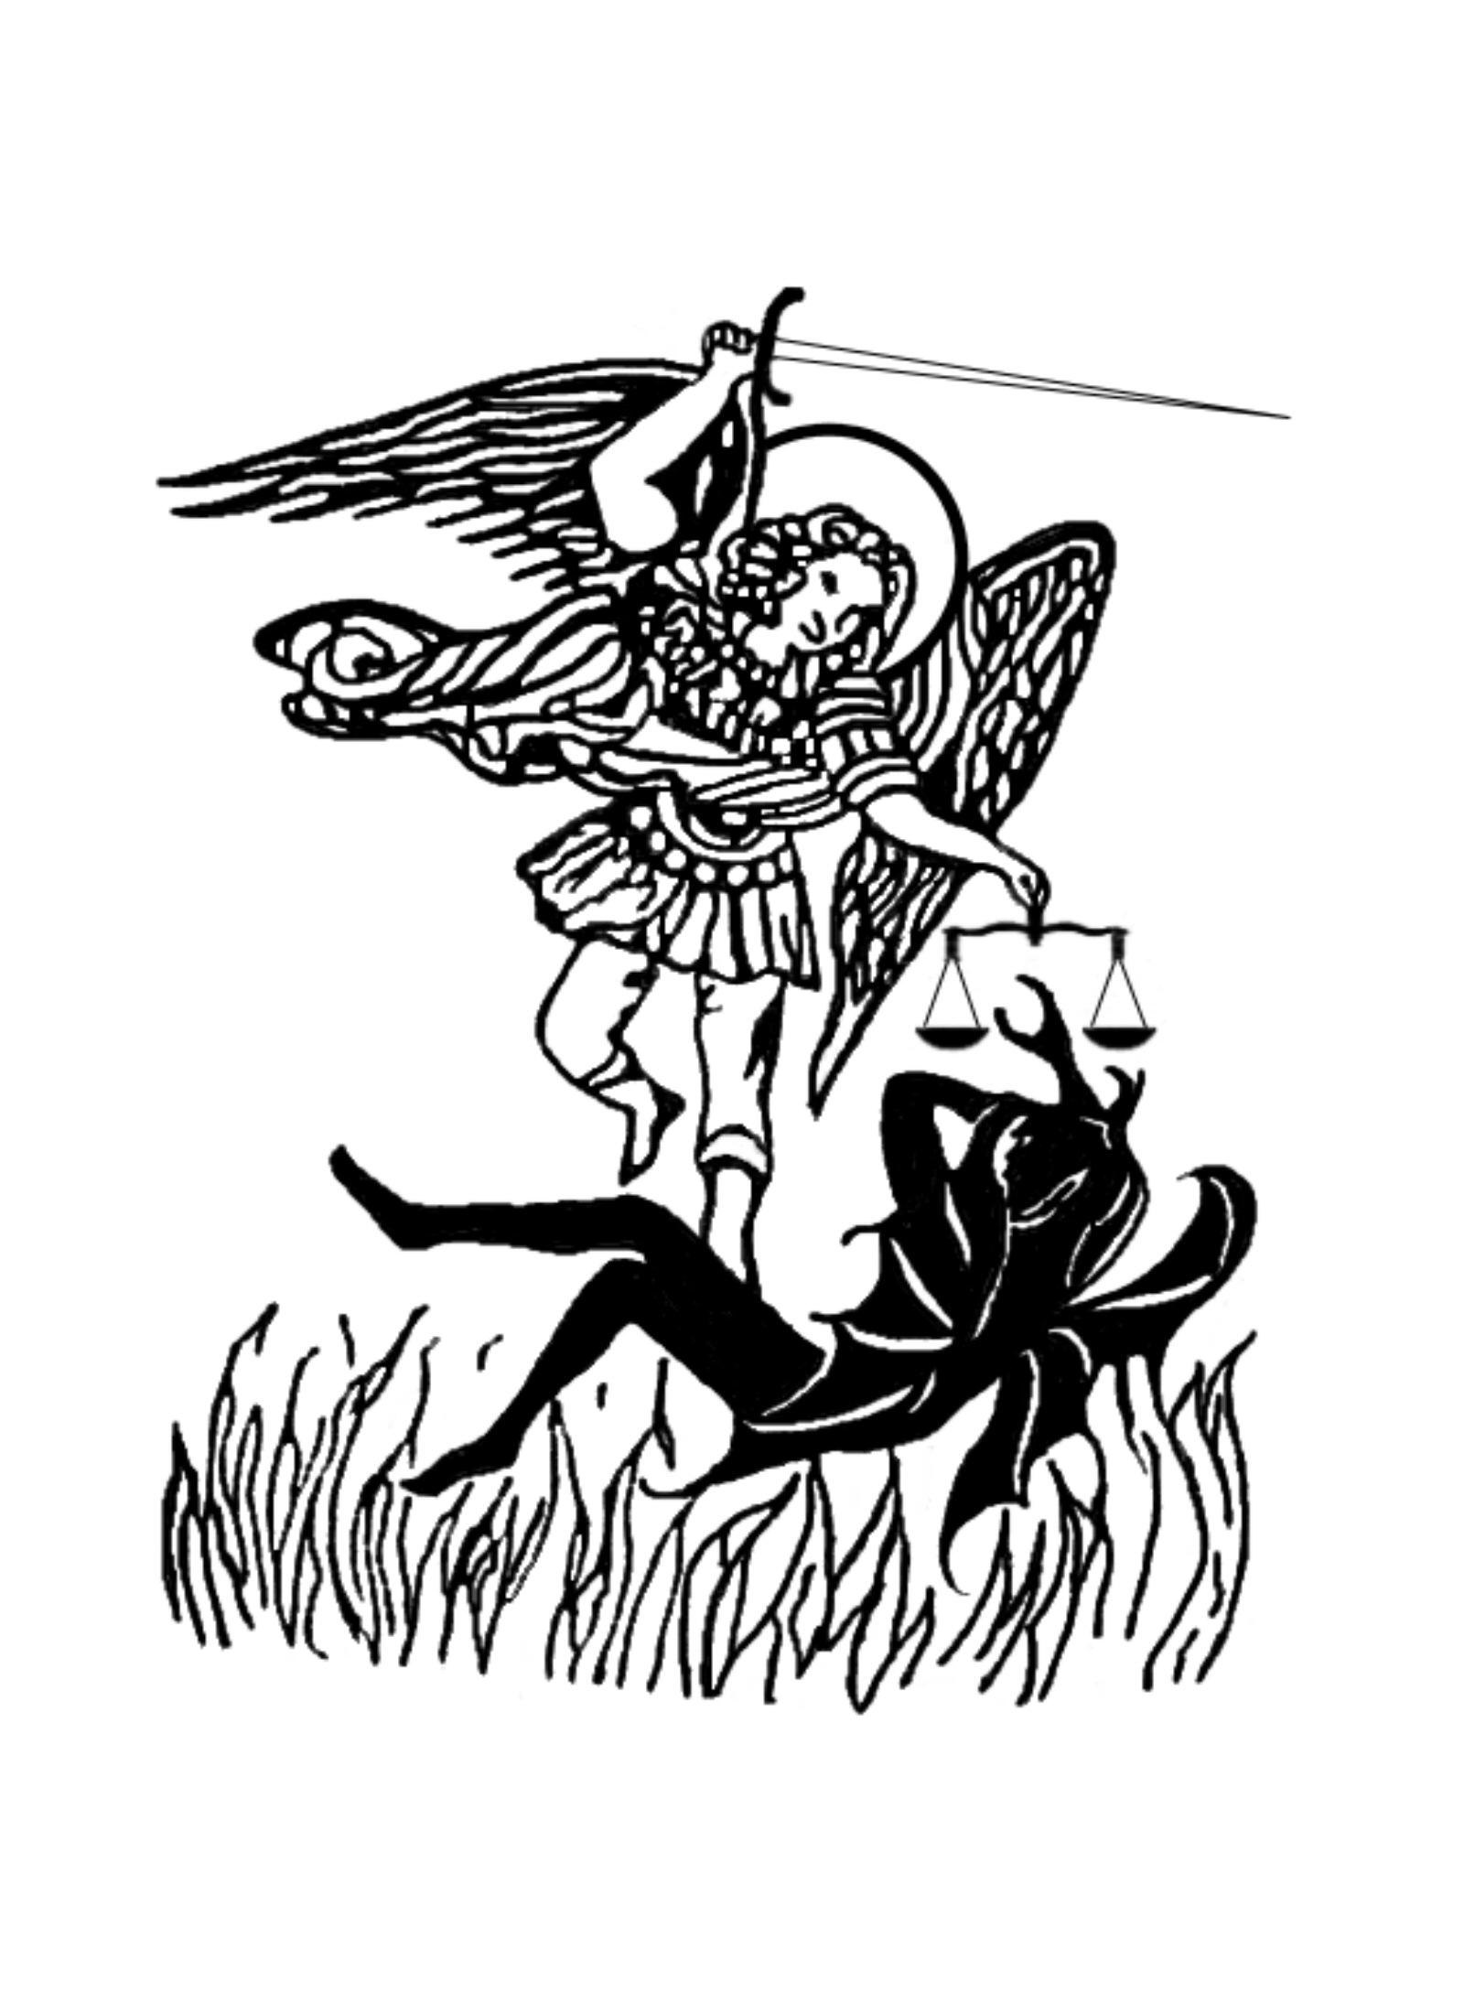
COURSE

FROM
SHATTER THE DARKNESS
www.shatterthedarkness.net

SESSION ONE

WELCOME AND OVERVIEW

1. Welcome to Freedom Encounters

2. What is a Freedom Encounter?

3. The basis of the Freedom Encounter is:

Jesus Christ-

Scripture-

The Spirit of God-

The mission of God in Christ-Luke 4:

17The scroll of the prophet Isaiah was handed to him. Unrolling it, he found the
place where it is written:
18"The Spirit of the Lord is on me,
because he has anointed me
to preach good news to the poor.
He has sent me to proclaim freedom for the prisoners
and recovery of sight for the blind,
to release the oppressed,
19to proclaim the year of the Lord's favor."^{[e]}
20Then he rolled up the scroll gave it back to the attendant and sat down. The eyes of everyone in the synagogue were fastened on him, 21and he began by saying to them, "Today this scripture is fulfilled in your hearing."

(1)

We see six points that relate to Freedom Encounter ministry.

A. Jesus is the one who is anointed to do these works.

B. It’s the Spirit of God who is operative in the work.

C. It is centered in the proclamation of Gods message.
Preach and proclaim John 3:16-17; Romans 1:16-17
Proclaiming (power evangelism) Mark 16:20 and Acts
Proclaiming and the works of Jesus John 12-17
Evangelism healing and deliverance and more Acts 4
Power in Word and work

D. Proclaim freedom for prisoners (this is an encounter)
Prisoners of what
Freedom is clear

E. Recovery of sight for the blind (lost and found)
What is lost?

Open their eyes and heart…

(2)

F. Release the oppressed
Freedom from oppression
Isaiah 58: 6….and untie the cords of the yoke,
to set the oppressed free
and break every yoke

MARK CHAPTER 5
AND
THE SHREDS OF HUMANITY

1. The condition of fallen man

2. The sin of man upon man

3. The effects of pain and trauma

4. The effects of the demonic

5. The undoing of sin, satan and fallen self

(3)

SESSION TWO
INTRODUCTION TO THE ISSUES

1. Freedom Encounters for all people!
Types and conditions

2. Salvation and changing the core of life.

3. Deliverance / set free from the reign of demons
A. Ownership
B. Oppression
C. Attack
D. Attachment
E. Demonization

In the SRA/MPD/DID/MC
Complexity

Untying the knots

(4)

4. Inner healing for personality/ mind and emotion
A. The horror, trauma and pain

B. The past effecting the present and future

C. When we find our own cures
Beach balls
Toxic ground
Halt who goes there

5. Re-Truth-ing / exchanging lies for living truth
A. What a lie can do

B. What the truth can do

6. Search and Rescue in Freedom Encounters
A. There is a cause for the pain/behavior

B. Layers personalities and human will

(5)

IN LIGHT OF CURRENT CONDITONS

1. The house that pain built
A. Universal
B. Extraordinary
C. The ramping up
D. Millions of sra/mpd/did/mmc
C. Where did they come from?
E. What can we do?

Just the overview
Satanic Ritual Abuse-
Multiple Personality Disorder-
Dissociative Identity Disorder-
Modern Mind Control-
Covens-
Military-
Law enforcement-
Verification-
Sub personalities-
Spiritual warfare-

(6)

Threats-
Protection-
Time-
Boundaries-
Institutions-
Families-
Handlers-

I BELIEVE THAT GOD WANTS DEEPLY TRAINED AND DEEPLY EXPERIENCED SERVANTS
HE WILL INVEST IN YOU
TO UNLEASH IN OTHERS

2 CORINTHIANS CHAPTER ONE
WHAT IS GOD DOING IN YOUR PROBLEMS?

(7)

